1. CentOS homepage:-

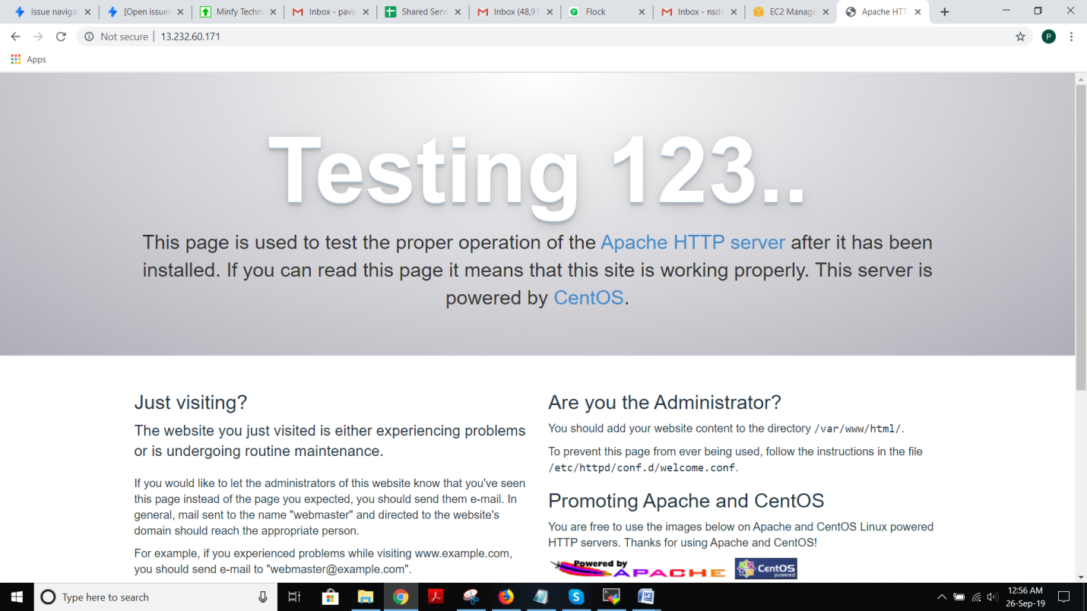

ii) PHP info page:-

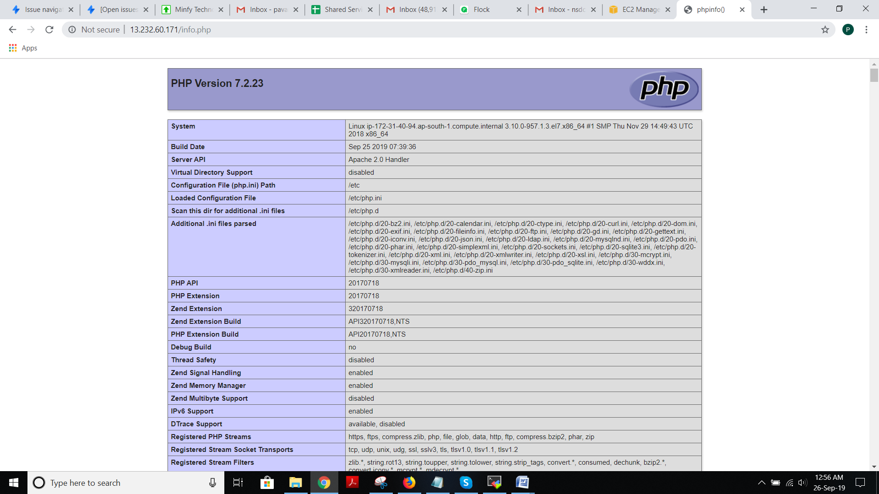

iii) Drupal Installation steps:-

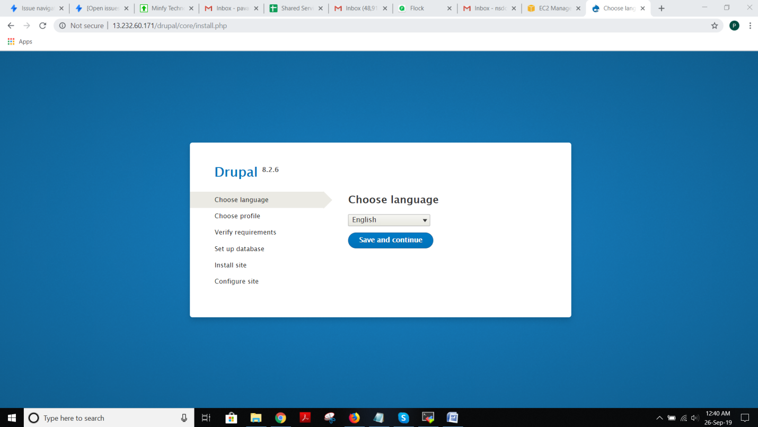

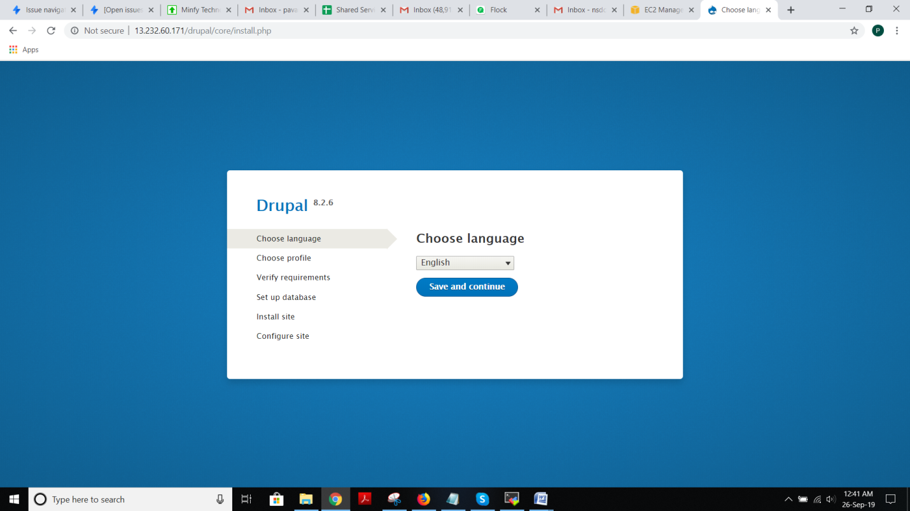

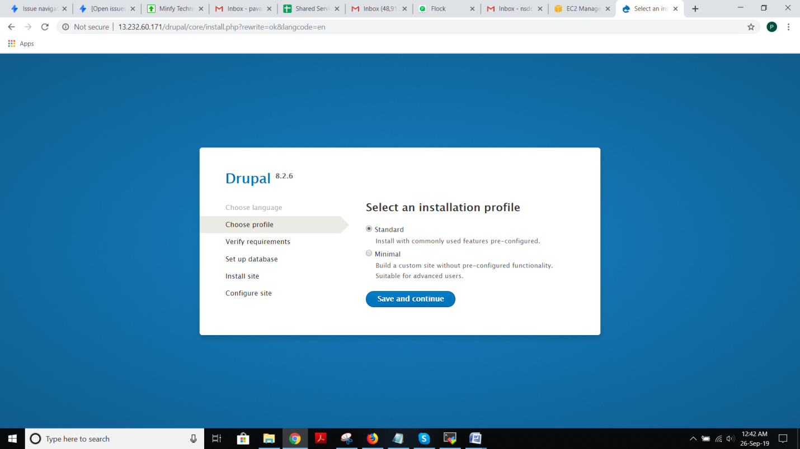

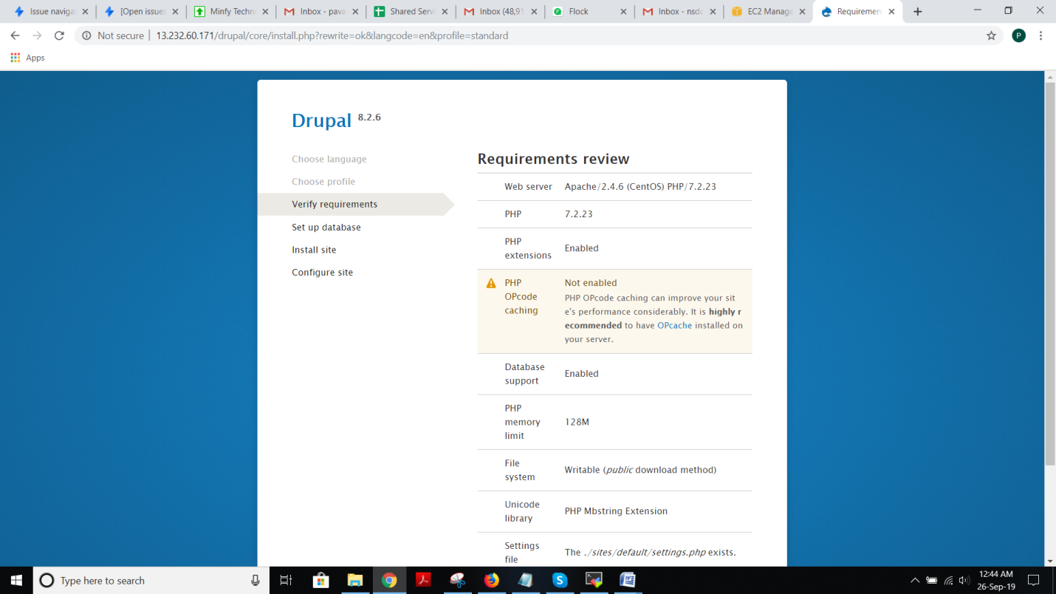

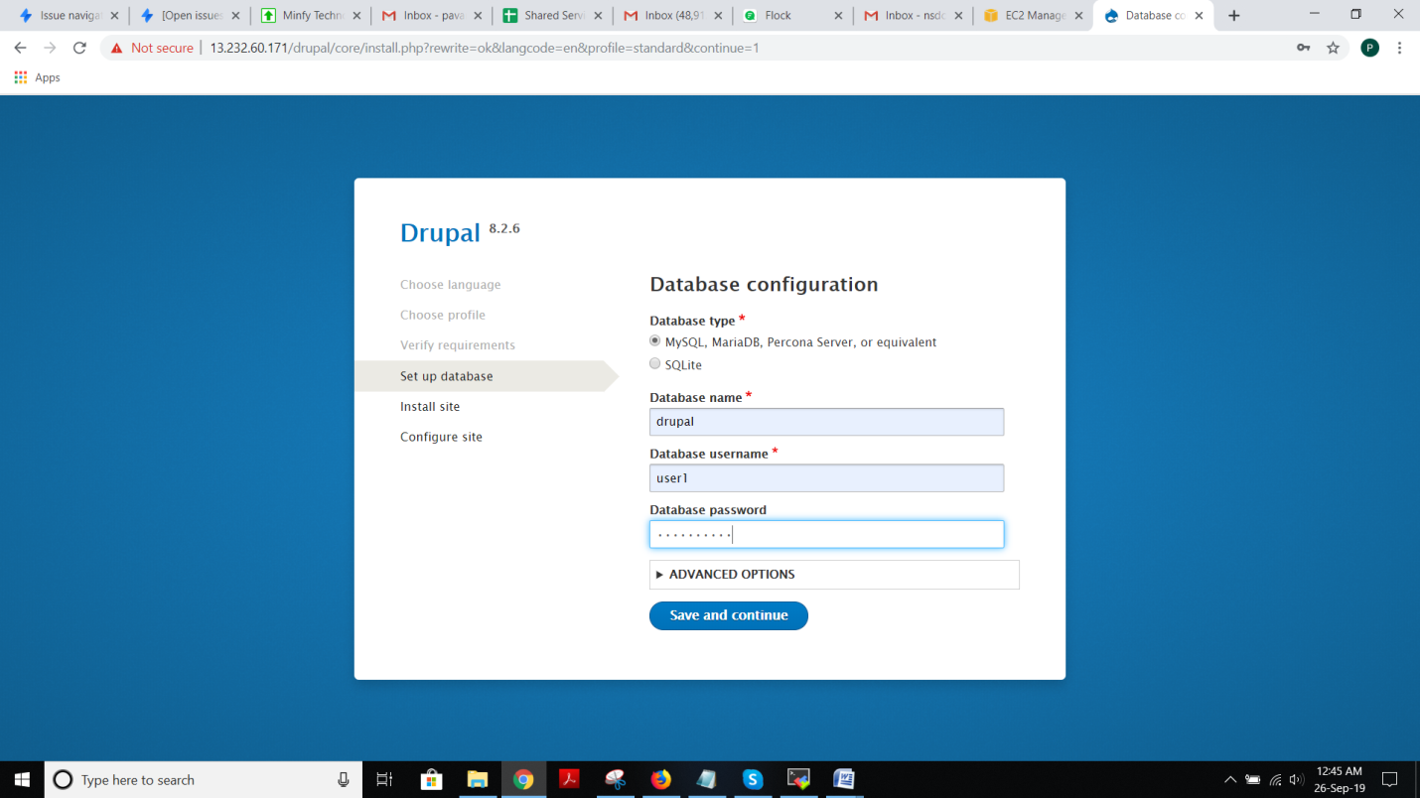

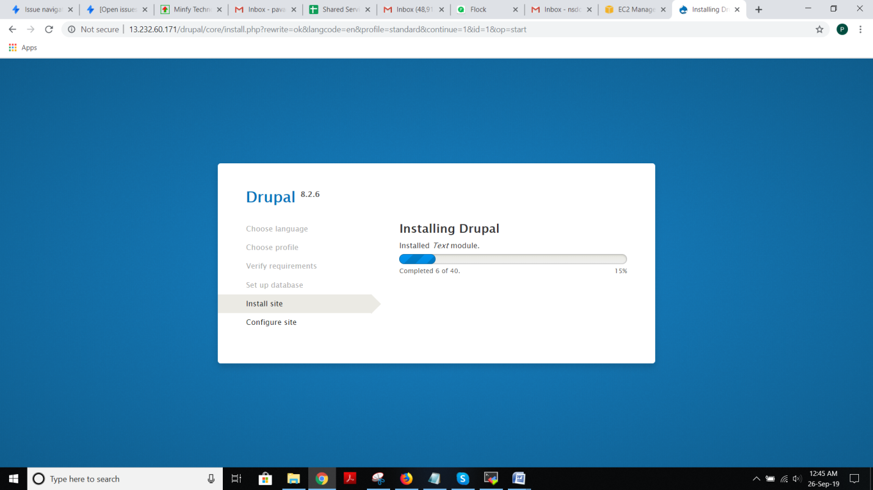

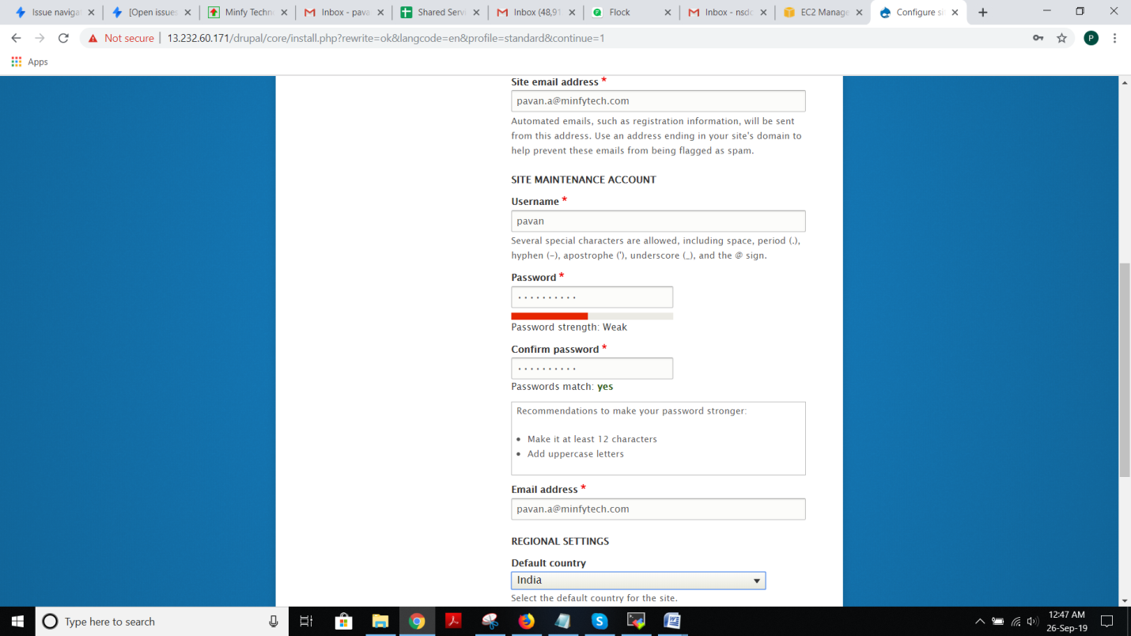

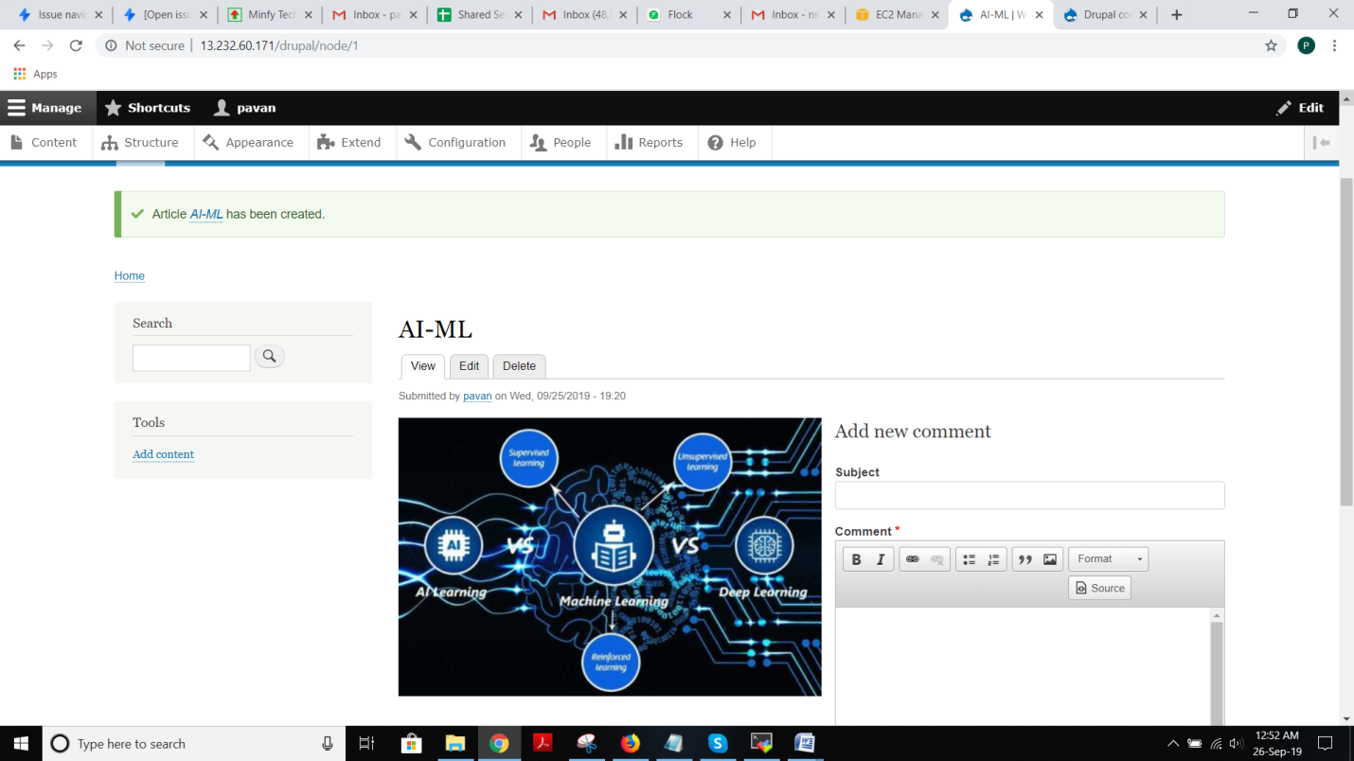

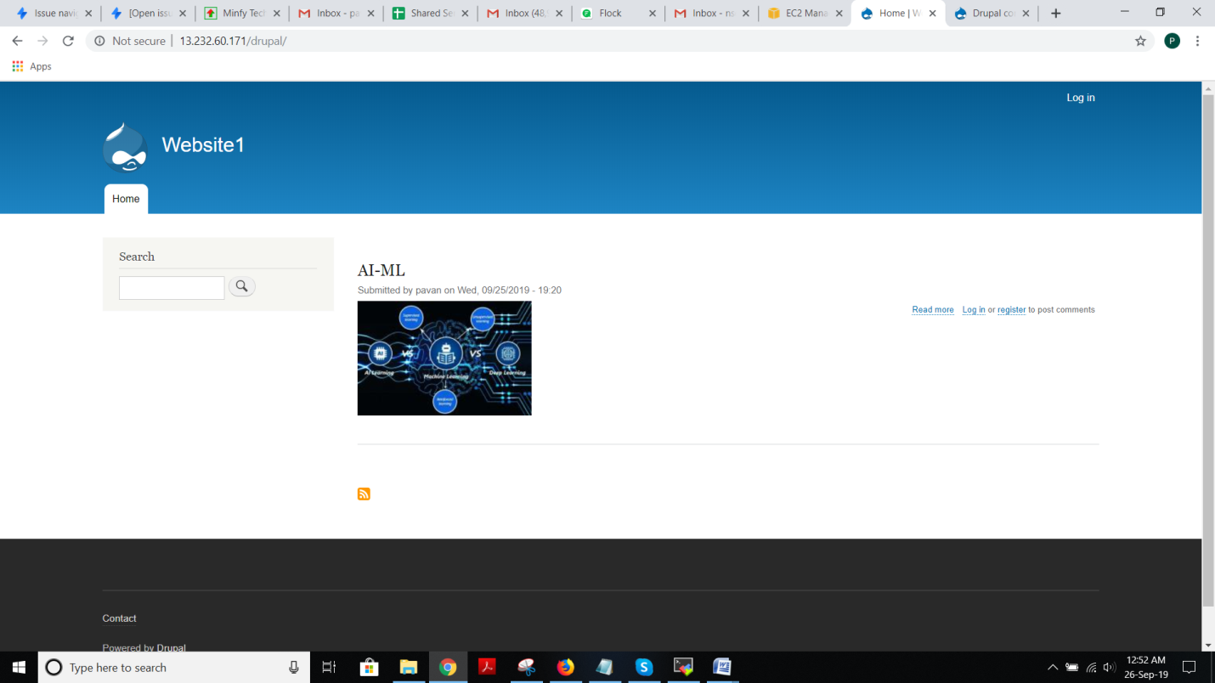

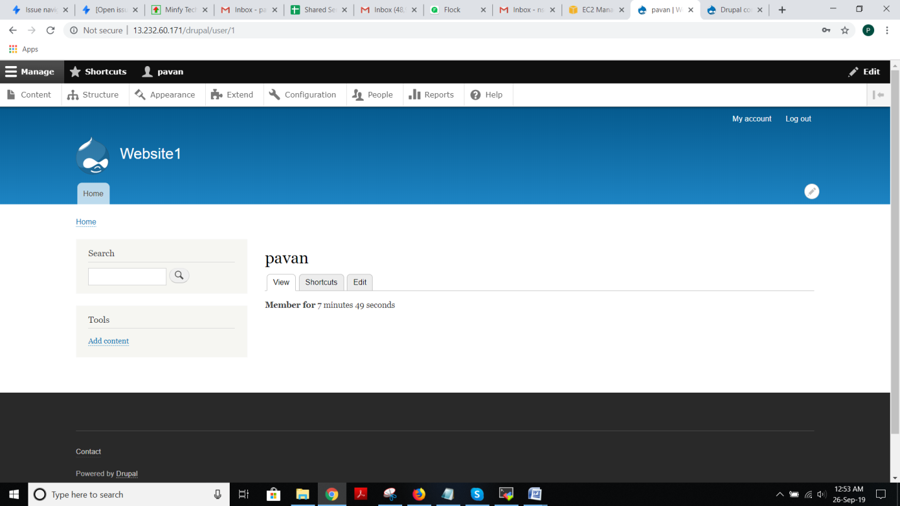

Attaching domainname to public IP :-

* Here I have attached my website pavan-chaser.online to my public IP, Instead of IP, I have pasted my domain name.

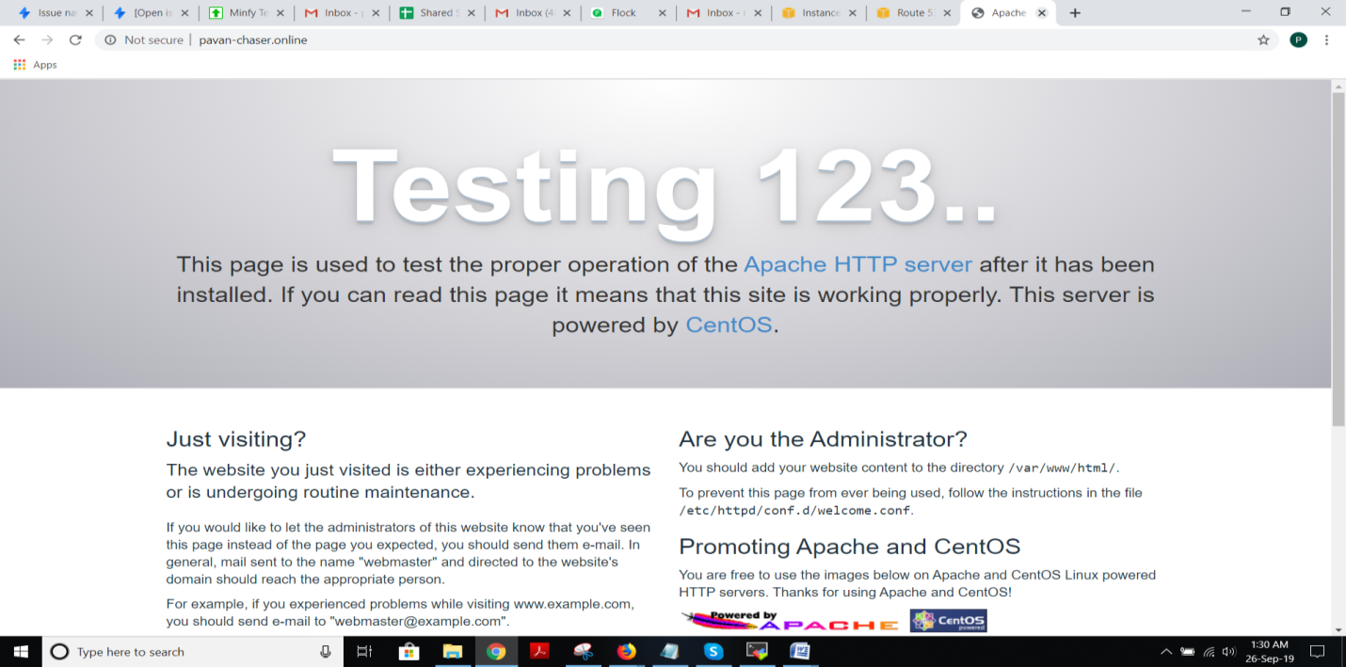

* Instead of typing IP address, we can access our website with domainname:-pavan-chaser.online/drupal

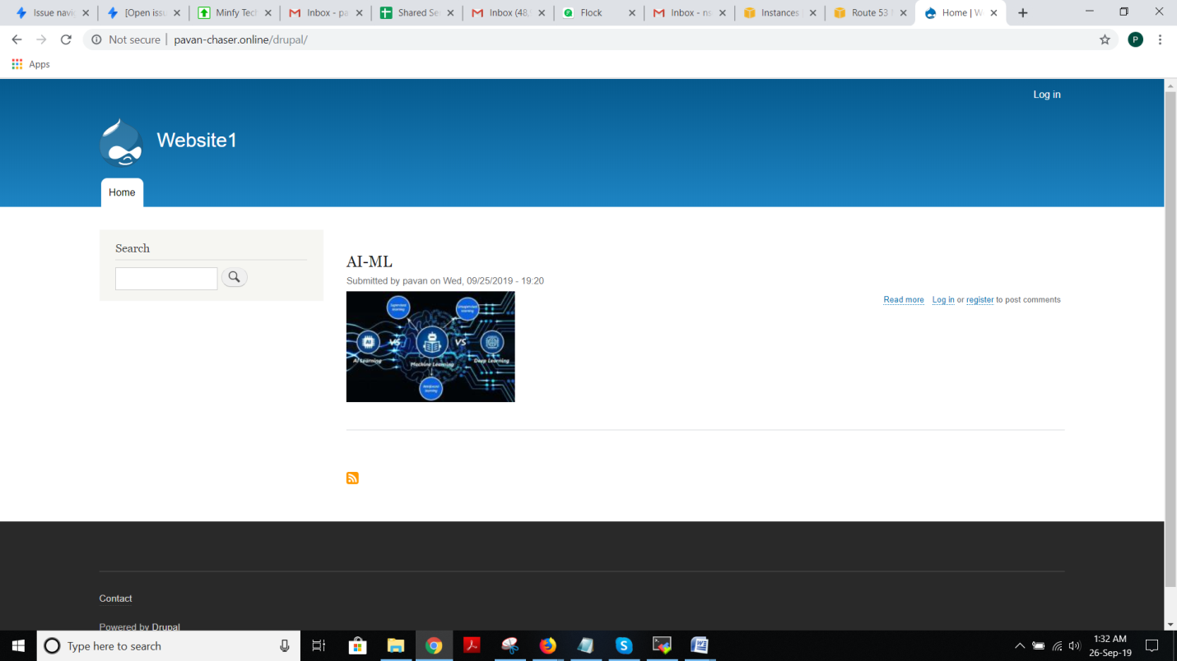

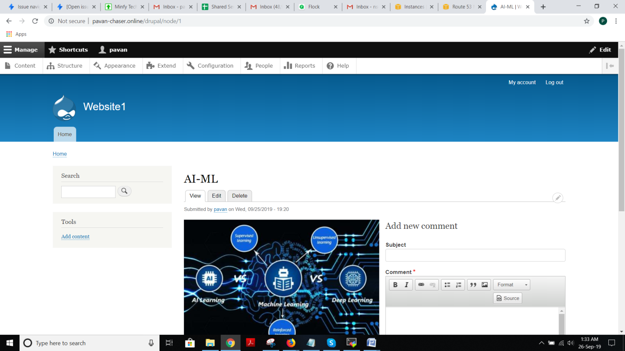

* **Installation of free SSL certificate:-**

1. I have installed SSL certificate for my own domain name :- pavan-chaser.online

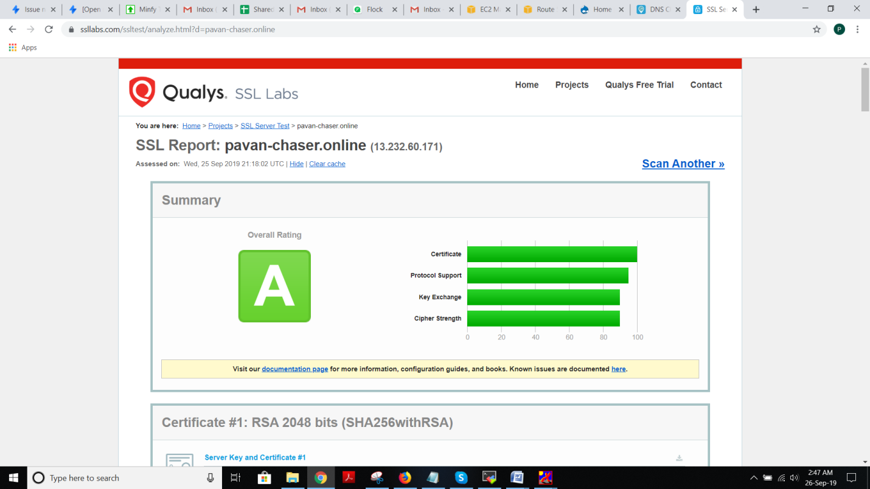

1. SSL certificate:-

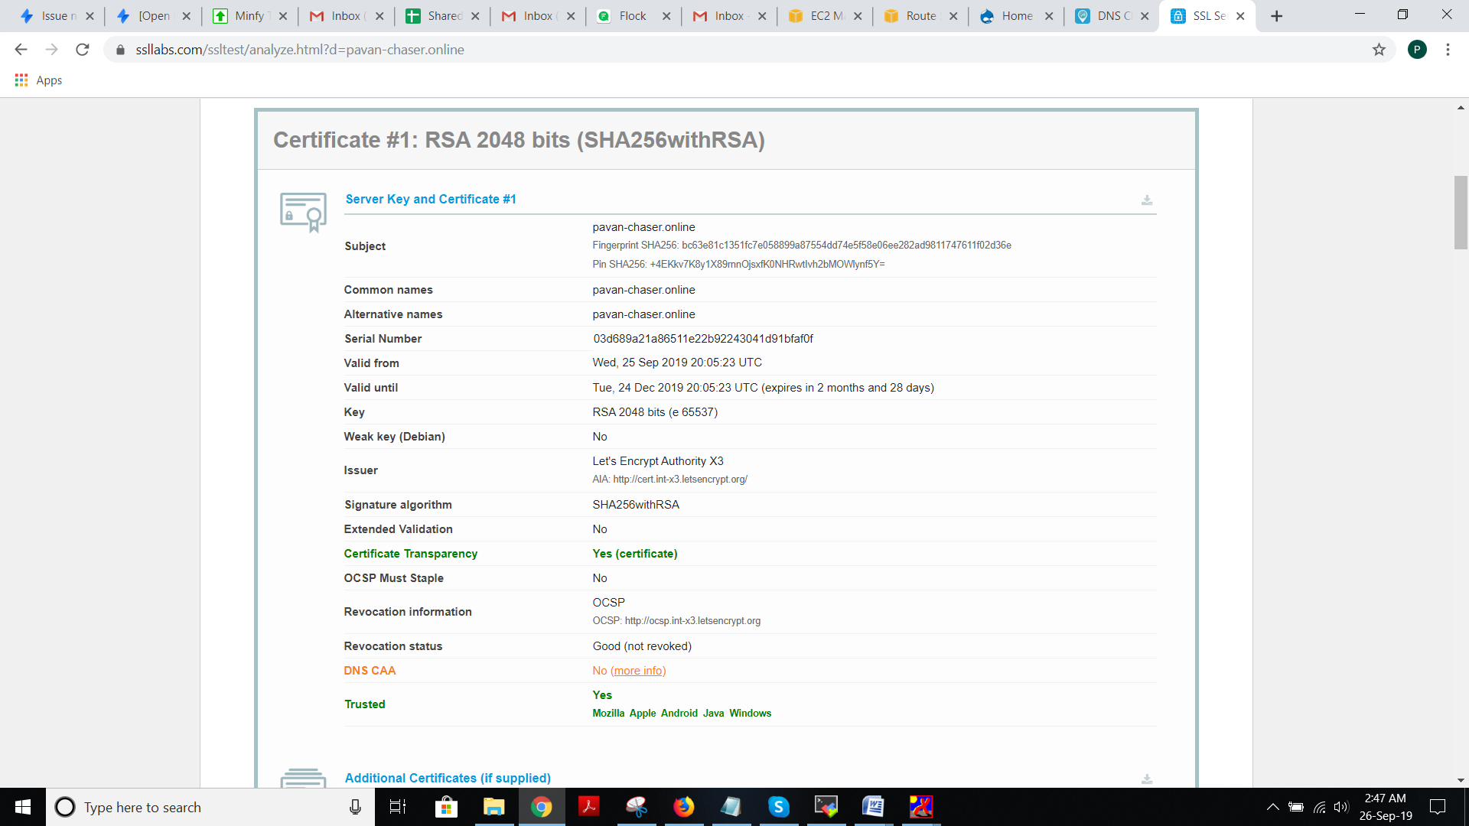

* <https://www.digitalocean.com/community/tutorials/how-to-secure-apache-with-let-s-encrypt-on-centos-7(SSL> certificate installtion)
* <https://www.tecmint.com/install-drupal-in-centos-rhel-fedora/(Drupal> installation on CentOS7)